Path Searching Towards The Symmetric Inward Open Structure of LeuT

Michelle A. Sahai¹, Benjamin J. Burnett¹, Sebastian Stolzenberg^{1,2}, Lei Shi¹, and Harel Weinstein^{1,3}

1 - Department of Physiology and Biophysics, Weill Cornell Medical College, Cornell University,
1300 York Avenue, New York, New York 10065, USA.
2 - Department of Physics, Cornell University, 109 Clark Hall, Ithaca, NY 14853-2501, USA.
3 - HRH Prince Alwaleed Bin Talal Bin Abdulaziz Alsaud Institute for Computational Biomedicine,
Weill Cornell Medical College, Cornell University, New York, NY 10065, USA.

Email: mis2066@med.cornell.edu, bjb2003@med.cornell.edu, ses2013@med.cornell.edu, les2007@med.cornell.edu, haw2002@med.cornell.edu

Corresponding Author: Harel Weinstein, Phone: 212-746-6358, Fax: 212-746-8690, Email:
haw2002@med.cornell.edu

Abstract
Recent high-resolution crystal structures from several protein families classified as secondary active transporters have been found to all share the same overall topology, termed the “LeuT-like fold”, which means that they all contain an inverted repeat of five transmembrane (TM) helices. Structures of one such transporter Mhp1 have facilitated studies aimed at describing the alternating access mechanism on a molecular level since it has been captured in different conformational states representing distinct stages of the transport cycle. However, the transport mechanism still remained partially understood for many transporters such as LeuT that until recently still lacked key conformational states that would allow a dynamic understanding of the mechanism. Here, we discuss the use of PathRover, a program that defines a set of low-energy, clash-free protein intermediates that subsequently generates a transition path between distinct conformational states. We use the crystal structures of Mhp1 that have been captured in three distinct states corresponding to the outward-facing, inward-facing and an occluded state to test the robustness of the method by computing a transition pathway between these states. This pathway was compared to the pathway created by the novel force-based approach Dynamic Importance Sampling (DIMS). We find that not only can PathRover model well represented structural intermediates along a putative transition pathway but that there is also a clear overlap between the PathRover intermediates and those from DIMS, validating the use of the program as an inexpensive alternative to force-based approaches. We then applied PathRover to calculate distinct pathways for LeuT from various crystal structures and a model to show that structural transitions between distinct conformational states come with limitations depending on the origin of the structures and the overall deviation between states. We ultimately used comparative molecular dynamics (MD) simulations to gain further insight into the dynamics involved in the transitions through the intermediate states for Mhp1 and LeuT captured by PathRover. This work provides grounding for an alternating access mechanism applicable to many transporters of this emerging superfamily.

Keywords: Alternating access mechanism, membrane proteins, Motion planning, PathRover, molecular dynamics simulation, neurotransmitter: sodium symporters, structural repeats, membrane transport, leucine transporter, monoamine transporter, benzyl-hydantoin
List of Abbreviations:

BetP - Corynebacterium glutamicum sodium-betaine symporter
CHARMM - Chemistry at HARvard Molecular Mechanics
DIMS - Dynamic Importance Sampling
LeuT - Aquifex aeolicus sodium-leucine symporter

MATCH - Multipurpose Atom-Typer for CHARMM
MD - Molecular Dynamics
Mhp1 - Microbacterium liquefaciens sodium-benzyl-hydantoin symporter
MP - Motion Planning
NAMD - NAnoscale Molecular Dynamics
NSS - Neurotransmitter: sodium symporter
PDB - Protein Data Bank, www.pdb.org
POPC - 1-palmitoyl-2-oleoylglycero-3-phosphocholine
POPE - 1-palmitoyl-2-oleoylphosphatidylethanolamine
POPG - 1-palmitoyl-2-oleoylglycero-3-phosphoglycerol
PRi.x - Motion Planning intermediate (see text)
RMSD - Root Mean Square Deviation
RRT - Rapidly Exploring Random Tree
SIO - Symmetric Inward Open Model
SMD - Steered Molecular Dynamics
TM - Transmembrane Domain
VMD - Visual Molecular Dynamics
vSGLT - Vibrio parahaemolyticus sodium-galactose symporter
Introduction
Secondary active transporters couple the free energy of the electrochemical potential to the uphill transport of one substrate against its concentration gradient with the energetically favorable downhill gradient of another substrate¹. The alternating access model put forward by Oleg Jardetzky in 1966 proposed a kinetic and thermodynamic explanation for this transport function². In the alternating access model, consecutive conformational changes occur to expose the central substrate-binding site to only one side of the membrane at a time. The transporter functions by cycling between different conformational states in which access to the central binding site is switched from the extracellular solution (outward-facing) to the intracellular compartment (inward-facing) (Figure 1).
The recent crystal structures of both the outward-facing and inward-facing conformational states for each of the sodium-coupled symporters LeuT^{3,4}, Mhp1^{5,6}, and BetP^{7,8}, provide support for the alternating access hypothesis as well as a detailed molecular insight into the atomic structures of the key protein states involved in substrate translocation. These transporters share the “LeuT-like fold” which is characterized by an internal pseudo-2-fold axis of symmetry relating the five N-terminal transmembrane (TM) helices of the first repeat to the following 5TM of the second repeat. These TM repeats are oriented in such a way as to form an axis of symmetry running parallel to the membrane plane through the center of the transporter, such that their TM topologies are inverted with respect to one another³. The discrete structural elements that are characteristic for this conserved transporter architecture include a 4TM helix bundle consisting of the first two helices of each repeat (TMs 1, 2, 6, 7), a 4TM hash domain consisting of the third and fourth helices of each repeat (TMs 3, 4, 8, 9) and two flexible TM arms corresponding to the fifth helix of each repeat (TMs 5 and 10)³.
The tertiary structure of Mhp1 resembles a similar “LeuT-like fold” to LeuT, and to several other secondary active transporters despite belonging to a different gene family, the nucleobase-cation-symport-1 gene family. It has been crystallized in three distinct conformational states; the outward-facing⁶ and inward-facing⁵ conformations and a distinct intermediate occluded state⁶. Thus, it represents an ideal target for understanding the basic principles that govern the overall conformational changes occurring in the alternating access mechanism for these proteins. By combining structural data and a novel simulation method (Dynamic Importance Sampling or DIMS) Shimamura et. al. (2010)⁵ were able to simulate the conformational transitions of the transporter. Their findings led them to conclude that Mhp1 dynamics are consistent with an alternating access mechanism in that this protein utilizes a system of synchronized gates to control the switching between the inward-facing and outward-facing state through the occluded-state⁵. The structures captured by crystallography correspond to the following functional states along the substrate translocation pathway (Figure 1): an outward-facing, open conformation (S1, PDB ID: 2JLN), where the substrate-binding site is fully accessible to the extracellular space and a sodium ion is bound, an occluded substrate- and ion-bound state (S4, PDB ID: 2JLO) and an inward-facing, open conformation (S7, PDB ID: 2X79) where the substrate-binding site is connected to the intracellular compartment and the sodium ion is still bound but the substrate is unbound. They report that the three conformations superpose well with a root mean square deviation (RMSD) of 0.7Å and that the major changes are primarily due to an approximate rigid body movement of the hash motif (TMs 3, 4, 8, 9) relative to the rest of the protein⁵. Other studies have led to similar conclusions^{9–12}.
The high-resolution crystal structure of a prokaryotic homolog to the solute carrier family 6 (SLC6) transporters, the leucine transporter (LeuT) from the thermophile bacterium Aquifex aeolicus provided the first atomic-level glimpse into the overall architecture of the “LeuT-like fold” transporters, implicating helices and residues that are responsible for the “gating” conformational changes that accompany ion binding and release as well as the substrate-binding and sodium-binding site(s)³. Although LeuT is evolutionary distant from the SLC6 (20–25% overall sequence identity), the protein has proved to be a suitable and highly useful structural and functional template for the SLC6 neurotransmitter:sodium symporter (NSS)¹³. In the central nervous system, the NSS transporters move their respective substrates (norepinephrine, serotonin and dopamine or amino acids) against their concentration gradient with the co-transport of sodium across the plasma membrane of presynaptic neurons^{14–17}. These transporters have gained significant attention because their dysfunction has been implicated in multiple debilitating central and peripheral nervous system diseases such as depression¹⁸, anxiety¹⁸, schizophrenia¹⁹ and Parkinson’s²⁰. More importantly, they are the target of therapeutic agents such as antidepressants, anticonvulsants and some psychostimulants as well as illicit substances such as cocaine and amphetamines.
Until recently, the only conformations observed in the crystal structures of LeuT represented two distinct states along the substrate translocation path: an open-to-out conformation (PDB ID: 3F3A)¹³ and an occluded state (PDB ID: 2A65)³ corresponding to S2 and S4 in Figure 1. Since it had proven difficult to trap and crystallize LeuT in an inward-facing (S7) state ²¹, the transport mechanism remained only partially understood. In response, computational efforts focused on modeling S7 (Figure 1) through a variety of ways. In one case, the crystal structure of a homologous secondary membrane transporter, vSGLT, which has been crystallized in an inward-open state, was used as a template for modeling LeuT in a similar inward-open conformation²². In other efforts, steered molecular dynamics (SMD) has also been used to drive the leucine substrate from the location found in the 2A65 crystal structure towards the intracellular compartment generating an inward-facing conformation^{23,24}. A slightly different model, termed the “rocking bundle”, capitalized on the pseudosymmetry exhibited by the “LeuT-like fold”^{25,26}. This model proposes that LeuT undergoes a direct conformational change from an outward-facing to inward-facing state by exploiting the pseudo-2-fold internal symmetry and “rocking” the 4TM-helix bundle composed of TMs 1, 2, 6 and 7 with respect to the hash domain composed of TMs 3, 4, 8 and 9. However, the recent crystal structure of a rationally designed mutant of LeuT capturing S7 in complex with an antibody fragment has revealed that only parts of the core move as a unit without a strict adherence to the pseudo-2-fold axis of symmetry¹². Despite the elucidation of many high-resolution crystal structures of LeuT and elegant biochemical^{3,12,13,27–30} and computational studies^{4,13,23–25,27,28,31–35}, a clear molecular mechanistic insight into the conformational changes related to the individual steps in the ion-coupled substrate transport cycle of LeuT are still unclear.
To gain insight into the substrate translocation pathway for the LeuT and Mhp1 transporters we use a combination of the Motion Planning (MP) module PathRover^{36,37} and Molecular Dynamics (MD) to model structural intermediates along a putative transition path between known structures which include crystal structures and models. This method has recently been shown to be successful in predicting intermediate states along the substrate translocation pathway for GltPh, a bacterial homologue of the excitatory amino acid transporters (EAATs); with an intermediate state that has also been supported with X-ray crystallography³⁶.
To test the robustness of the PathRover method we first computed the structural intermediates along a putative transition path between the two distinct crystal structures of Mhp1, S1 (PDB ID: 2JLN)⁶ and S7 (PDB ID: 2X79)⁵ and whose transition pathway has been calculated previously⁵. The PathRover calculated intermediates were then compared to those intermediates previously calculated from the force-based DIMS approach⁵. We find that there is a clear overlap between the PathRover computed intermediates and the DIMS intermediates and that the transition among states is well represented by PathRover. Additionally, we find the PathRover program can be used as a timely and computationally inexpensive alternative to force-based approaches like DIMS. We subsequently characterized the structural features that accounted for the largest and smallest motions in these intermediates along the substrate translocation pathway. We observe that a decomposition of the RMSD between states show that the largest contributions (~6-10Å) are from particular loops regions.
For LeuT, we constructed three pathways. One for intermediates from the rationally designed crystal structures of the outward-facing state (S1, PDB ID: 3TT1) to the inward-facing state (S7, PDB ID: 3TT3), a second for intermediates from the crystal structure of the open-to-out state (S2, PDB ID: 3F3A) to a model of the inward-facing state that exploits the pseudo-2-fold internal symmetry observed in the 2A65 crystal structure, hereafter referred to as the symmetric inward-open (SIO) model. Thirdly, intermediates were calculated from the crystal structure of the occluded state (S4, PDB ID: 2A65) to the SIO model. We find that PathRover was unable to construct a complete transition pathway from either S2 or S4 to the SIO model. . These results were compared to the outward-facing ⇔ inward-facing pathway that was constructed from the intermediates of the crystal structures 3TT1 and 3TT3.
Additionally, we performed full atomistic MD simulations to compare the overall structural transitions between Mhp1 and LeuT in attempt to further support any large-scale structural changes seen in the PathRover intermediates

2. Methods
2.1 Symmetric inward-open (SIO) model construction. The SIO model of the inward-facing conformation of LeuT was constructed using the protocol described previously²⁵ (Figure S1). Residues in the first repeat were modeled by using the structure of the second repeat as a template and vice versa. The SIO model was modeled on the “rocking bundle” model since the pathway proposed for the model from the steered molecular dynamic simulations²⁴ involves only small changes in protein conformation relative to the crystal structure, whereas the proposed pathway from the “rocking bundle” model shows significant movement of TMs 1, 2, 6 and 7.

2.2 Crystal structure preparation. Crystal structures were obtained from the Protein Data Bank³⁸ and Modeller³⁹ was used to add missing residues. All side-chain atoms except C_{β} were removed prior to performing the PathRover protocol.

2.3 Motion Planning. To model conformations representing intermediates between the outward- and inward-facing conformations we followed a protocol described previously that uses the Motion Planning (MP) module “PathRover”³⁷, implemented in the Rosetta docking distribution³⁷. In PathRover, a protein structure is represented by the dihedral angles of its heavy-atom backbone and the C_{β} atoms. From the starting “source” representation, the conformational space of the protein is explored with a Rapidly Exploring Random Tree (RRT) algorithm, using the “RMSD Minimize” predicate, to bias the search towards a “target” conformation³⁶.
For Mhp1, the “source” and the “target” are the crystal structures for the outward- (S1, PDB ID: 2JLN) and inward- (S7, PDB ID: 2X79) conformations with a backbone Cα RMSD difference of 3.2 Å between the two structures, and they serve alternately. For LeuT, we constructed intermediates towards the “target” SIO model from two separate crystal structure “sources”, S2 (PDB ID: 3F3A) and S4 (PDB ID: 2A65). Two separate paths, S2 ⇔ S7_{SIO} and S4 ⇔ S7_{SIO,} were constructed since there are large backbone Cα RMSD deviations between the SIO “target” and “sources”, 7.0Å and 6.7Å, respectively, and would offer a better sampling in the path ensemble. For the rationally designed mutant crystal structures of LeuT the “source” and the “target” are the crystal structures for the outward- (S1, PDB ID: 3TT1) and inward- (S7, PDB ID: 3TT3) conformations, and they serve alternately. There is a RMSD difference of 3.8 Å between the backbone Cα atoms of these two structures. The MP paths are produced with degrees of freedom (DOF) for the conformational search for all TMs except TM 11 and TM 12 because only the first two 5TM inverted repeats have been implicated in contributing to the transitions along the substrate translocation pathway¹⁰. The complete set of PathRover parameters used is presented in Table SI.
In general, the path-searching strategy was to use the path conformation with the lowest possible target RMSD from each run, and to restart the search from this conformation. Twenty five such subsequent replicated restarts were used to construct an ensemble of MP conformations for each path. This strategy was shown to be more successful than using single PathRover “RMSD Minimize” predicate runs³⁶.
For Mhp1, along the ensemble path, outward-facing ⇔ inward-facing, representative intermediates were chosen in 0.5Å ranges from the “source” and target” and from the overlap near the occluded intermediate structure having the lowest mean pairwise RMSD. The representative intermediates are denoted as PRi.S1_{Mhp1}, PRi.S4_{Mhp1}, PRi.S7_{Mhp1}. In a similar way three intermediates were chosen for LeuT along the outward-facing ⇔ inward-facing path for the crystal structures 3TT1 and 3TT3. These intermediates were denoted as PRi.S1_{LeuT-mutant}, PRi.S4_{LeuT-mutant}, PRi.S7_{LeuT-mutant}.

2.4 Molecular Dynamics Simulations. Six MD simulations on the chosen intermediate structures from Methods 2.3 were considered. This was done to allow any intermediate structure found by PathRover to relax towards a physiologically relevant intermediate state and avoid any unrealistic attractor states. The six starting intermediate structures chosen for the MD simulations for Mhp1 from the outward-facing ⇔ inward-facing path were PRi.S1_{Mhp1}, PRi.S4_{Mhp1}, PRi.S7_{Mhp1} and for LeuT from the outward-facing ⇔ inward-facing path were PRi.S1_{LeuT-mutant}, PRi.S4_{LeuT-mutant}, PRi.S7_{LeuT-mutant}. The substrate, leucine, was positioned in the binding site of PRi.S4_{LeuT-mutant} by aligning the amine group and the hydrophobic portion with those of the substrate in the LeuT structure, 2A65. Benyzlhydantoin was also modeled into PRi.S4_{Mhp1} in a similar manner by superimposing 2JLO onto PRi.OcC_{Mhp1}⁵. Because the binding stoichiometry of leucine/sodium in LeuT is 1:2 the final models for PRi.S1_{LeuT-mutant}, PRi.S4_{LeuT-mutant}, also included two Na⁺ ions positioned equivalently to those in 3TT1³. The intermediate PRi.S7_{LeuT-mutant} did not have sodium ions, specifically Na2, as residues were carefully mutated to prevent ions from binding¹². For the Mhp1 the binding stoichiometry of benzyl-hydantoin/sodium is 1:1 intermediates, so Na+ was modeled into the ion-binding site by superimposing the occluded state structure (2JLO) by a backbone RMSD fit onto the Mhp1 intermediate structures, PRi.S1_{Mhp1}, PRi.S4_{Mhp1}, PRi.S7_{Mhp1}. The side-chains that were removed prior to the PathRover protocol were re-added using Schrödinger's Protein Preparation Wizard module⁴⁰.
The Mhp1 intermediates, PRi.S1_{Mhp1}, PRi.S4_{Mhp1}, PRi.S7_{Mhp1} were inserted into a mixed bilayer containing 1-palmitoyl-2-oleoylphosphatidylethanolamine (POPE)/1-palmitoyl-2-oleoylglycero-3-phosphoglycerol (POPG) lipids in the ratio 4:1, as previously described. The LeuT intermediates, PRi.S1_{LeuT-mutant}, PRi.S4_{LeuT-mutant}, PRi.S7_{LeuT-mutant}, were inserted in a 1-palmitoyl-2-oleoylglycero-3-phosphocholine (POPC) lipid bilayer used in previous simulation studies. The resulting systems were solvated and contain free sodium and chloride ions at a physiological concentration of 100 mM for the Mhp1 intermediates and 150mM for the LeuT intermediates^{24,27,41,42}. Simulations of these systems were constructed with VMD and run using NAMD⁴³. During the equilibration of the intermediates in their environment, the backbones were initially fixed and then harmonically constrained, and water was restrained by small forces from penetrating the protein-lipid interface. The constraints were released gradually in three steps of 300 ps each, changing the force constants from 1, to 0.5, and 0.1 kcal/(mol Å²), respectively. The all-atom CHARMM27 force field was used throughout. Constant temperature (310 K) was maintained with Langevin dynamics, and 1 atm constant pressure was achieved by using the hybrid Nosé-Hoover Langevin piston method on a flexible periodic cell. In all simulations, SHAKE (rigidBonds)⁴⁴ and SETTLE⁴⁵ were applied to constrain the lengths of all bonds that involve a hydrogen. Each Mhp1 system contained ~200,000 atoms in simulation boxes of 160 x 160 x 100 Å³, while the LeuT systems contained ~270,000 atoms in a box with final dimensions of 180 x 180 x 100 Å³. In total 300ns of simulation were run, with ~50ns for each of the six systems.

2.5 Parameterization of benzyl-hydantoin. We used the multipurpose atom-typer for CHARMM (MATCH)⁴⁶ to automatically assign partial charges and parameterize the Mhp1 substrate, benzyl-hydantoin. This method is comparable to the recent CHARMM general force-field⁴⁷ and thus compatible with the CHARMM22 forcefield implemented in NAMD. In this way we avoided the problem of using “mix and match force fields” seen in many biomolecular simulations.

3. Results and Discussion
3.1 Structural Intermediates obtained from Motion Planning and Molecular Dynamics for Mhp1.
The Motion Planning (MP) module “PathRover” was used to generate putative outward-facing ⇔ inward-facing clash-free paths, connecting the two crystal structures of Mhp1, S1 (PDB ID: 2JLN) and S7 (PDB ID: 2X79). Three generated PathRover intermediates (PRi), PRi.S1_{Mhp1}, PRi.S4_{Mhp1}, PRi.S7_{Mhp1}, were chosen and served as inputs for MD simulations. Figure 2(a) illustrates the progression of the structural intermediates obtained with the MP PathRover algorithm as expressed by their RMSD from the corresponding crystal structures. The plot of S1_{Mhp1} against S7_{Mhp1} shown in Figure 2(a) is calculated from the Cα atoms of the helices in the compared structures. It shows that the intermediate conformations determined with MP span the entire range of the RMSD between the S1_{Mhp1} and S7_{Mhp1} structures, = 3.2Å.
To evaluate the feasibility of the MP method in calculating putative intermediates along the substrate translocation pathway we compared the MP intermediates with the intermediates calculated from Dynamic Importance Sampling (DIMS). Figure 2(b) depicts the RMSD landscape for all DIMS computed intermediates along the S1_{Mhp1} ⇔ S7_{Mhp1} pathway. This data was obtained and presented here with the permission of the authors⁵. The comparison of MP intermediates and DIMS intermediates is shown in Figure 2(c). As an example an individual path calculated from DIMS, shown in red, is superposed onto the MP path. It is reassuring to find a clear overlap exists between the MP computed intermediates and this particular set of DIMS intermediates. We find the same overlapping trend with the majority of the calculated DIMS intermediates.
To find the RMSD between the MP and DIMS intermediates we picked overlapping structures from each path and compared their superposed backbone Cα atoms. A few of such points on each path are shown for clarity in purple and orange squares in Figure 2(c). We find that the minimum RMSD between the two paths is ~1.5 Å, providing further support that the transition among states is well represented by PathRover and comparable to the states obtained from the force-based approach DIMS. We also find that the hash domain (TMs 3, 4, 8, 9) pivots along TM3 and “rocks” relative to the helix bundle (TMs 1, 2, 6, 7) during the transition from the outward-facing (S1) to inward-facing (S7) conformation generated by PathRover.
To gain further insight into the nature of the transition path predicted by PathRover, we additionally characterized important structural features of Mhp1 intermediates and expressed them by their RMSD deviations from the crystal structures as seen in Figure 3(a-f). Important features include the TM regions comprising the bundle (TMs 1, 2, 6 and 7) and hash motifs (TMs 3, 4, 8 and 9), the flexible arm helices (TMs 5 and 10) and the small extracellular and intracellular helices (Figure 3a). The TM regions depicted in Figure 3(b) span the entire RMSD range, = 3.2Å, and are observed to fully transverse the transition path. Flexible residues comprising DOF parameters used in the MP algorithm, seen in Figure 3(c), appear to account for a RMSD deviation within the range of 3.2Å ≤ ≤ 4Å and were not observed to fully transition between states. To delineate the specific contributions of motifs within the flexible residues, we separately compare the small helices comprising the intracellular “thin” gate TM5, the extracellular loop between TMs 9-10⁵ and the extracellular loop connecting TMs 7-8(Figures 3(d-f)). The intracellular “thin” gate (Figure 3(d)) and extracellular loop (Figure 3(e)) are within the ranges of ≤ 3.2Å and 3.2Å ≤ ≤ 4Å, respectively and appear to explore a large degree of conformational space. Interestingly, PathRover was not able to generate a transition path for the small flexible extracellular loop connecting TMs 7-8 (Figure 3(f)). We speculate that this barrier accounts for the inability of PathRover to propagate the flexible region as a whole along the transition path (compare Figures 3(c) and 3(f)).
The representative intermediates, PRi.S1_{Mhp1}, PRi.S4_{Mhp1}, PRi.S7_{Mhp1}, defined in the Methods 2.3 section, are depicted in Figure 4a. These intermediates were chosen in 0.5Å ranges from the “source” (PRi.S1_{Mhp1}) and “target” (PRi.S7_{Mhp1}) and from the overlap near the occluded intermediate structure having the lowest mean pairwise RMSD (PRi.S4_{Mhp1}). From these snapshots we can consolidate the observances from the RMSD decompositions seen in Figure 3(f). We observe the extracellular loop connecting TMs 7-8 (in magenta) appearing to switch from a conformation that is closer to the bundle motif (red) towards a conformation closer to the hash motif (blue) in a “rocking” motion about TM3. MD simulations of these structures revealed that the sodium ion is bound stably in the outward (PRi.S1_{Mhp1}) and occluded state (PRi.S4_{Mhp1}) but rapidly unbinds Mhp1 in the inward state (PRi.S7_{Mhp1}),diffusing into the bulk water on the intracellular side of the membrane. These simulations also show that Benzyl-hydantoin is stably bound in the occluded state and blocks the pathway of the sodium ion to the extracellular side. Additionally, it appears that no substantial change in conformation is observed for TM1 and 6 within the bundle (TMs 1, 2, 6, 7) motif.
These findings qualitatively agree with the observations made from previous simulations of Mhp1⁵ and LeuT^{23,48}. We independently find that the bundle and hash motif of Mhp1 adhere to the “rocking bundle” hypothesis but not strictly as rigid bodies as important structural features such as the intracellular “thin” gate TM5, the extracellular loop between TMs 9-10 and the small flexible extracellular loop connecting TMs 7-8 show varied deviations transitioning from the outward-facing to inward-facing conformation.

3.2 Structural Intermediates obtained from Motion Planning and Molecular Dynamics for LeuT.
PathRover was used to generate two putative clash-free paths, S2_{LeuT} ⇔ S7_{SIO} (Figure 5(a-e)) and S4_{LeuT} ⇔ S7_{SIO} (Figure S2), connecting the symmetric inward open (SIO) model to two crystal structures of LeuT, 3F3A and 2A65, respectively. These RMSD plots show that PathRover was unable to calculate intermediates from the crystal structures to the SIO model. Generating intermediates in the reverse direction, from the SIO model to crystal structures of LeuT yielded some intermediate states but not complete paths. In both cases, PathRover failed to propagate a complete transition path due to significant steric clashes introduced within LeuT.
Similarly to Mhp1, important structural features present in the MP calculated intermediates were characterized and expressed by their RMSD deviations from the structures (in this case the SIO model and crystal structures) as seen in Figure 5(a-e) and Figure S2(a-e). The TM regions are depicted in blue in Figure 5(b) and Figure S2(b). The flexible residues in red, comprising the DOF parameters used in the MP algorithm, are depicted in Figure 5(c) and Figure S2(c). The extracellular loops, EL2 and EL4 are presented in Figures 5(d-e) and Figure S2(d-e). In general, the TM regions do not deviate from the original RMSD (Figure 5b and Figure S2(b)), while the DOF parameters account for a RMSD deviation ≥ 2Å from the original RMSD (Figure 5c and Figure S2(c)). The extracellular loop, EL2 (Figure 5(e) and Figure S2(e)) deviates by ≥ 4Å from the original RMSD, while EL4 (Figure 5(d) and Figure S2(d)) has a more significant spread of ≥ 10Å , for calculated intermediates. No intermediate states were chosen along either transition path for input into MD simulations, as they were both incomplete.
Inferences made from these pathways should be carefully considered since the transition pathways could not be fully modeled. It appears at least that the SIO model could locate some intermediate states going towards the outward-facing (PDB ID: 3F3A) and occluded (PDB ID: 2A65) crystal structures but not the other way around. We speculate that this could be due to large rearrangements of the transport domains or steric clashes within the protein that prevent a transition path.

3.3 Structural Intermediates obtained from Motion Planning for a rationally designed mutant of LeuT.
Intermediates were calculated for the two rationally designed mutant structures of LeuT, S1_{LeuT-mutant} ⇔ S7_{LeuT-mutant}, using the MP algorithm. The plot of S1 against S7 (Figure S3) is calculated from the Cα atoms of the helices in the compared structures and illustrates the progression of the structural intermediates obtained with the MP PathRover algorithm as expressed by their RMSD from the crystal structures (see pdb entries “3TT1” and “3TT3”). It illustrates that the intermediate conformations determined with MP span the entire RMSD range between the S1 and S7 structures, = 3.8 Å.
Important structural features for the calculated intermediates along the S1_{LeuT-mutant} ⇔ S7_{LeuT-mutant} path (Figure S3) were similarly characterized and expressed by their RMSD deviations from the crystal structures as in Mhp1 and LeuT. These results are shown Figure 6(a-f). The TM regions are depicted in Figure 6(b) nearly span the entire transition pathway, with an RMSD range, = 3.8Å. Flexible residues comprising DOF parameters used in the MP algorithm as seen in Figure 6(c) account for a RMSD deviation within the range of 3.8Å ≤ ≤ 6Å. The extracellular loops EL4 and EL2 are presented in Figures 6(d, e). EL4 (Figure 6(d)) has the largest spread within the range of 1Å ≤ ≤ 10Å while EL2 (Figure 6(e)) is within 3.8 Å ≤ ≤ 6Å. TM1a in Figure 6(f) deviates substantially within a range of 2Å ≤ ≤ 8Å.
Like Mhp1, representative intermediates, PRi.S1_{LeuT-mutant}, PRi.S4_{LeuT-mutant}, PRi.S7_{LeuT-mutant}, defined in the Methods 2.3 section, are depicted in Figure 4b. These intermediates were also chosen in 0.5Å ranges from the “source” 3TT1 (PRi.S1_{LeuT-mutant}) and “target” 3TT3 (PRi.S7_{LeuT-mutant}) and from the overlap near the occluded intermediate structure having the lowest mean pairwise RMSD (PRi.S4_{LeuT-mutant}). We immediately observe in these PathRover snapshots that TM1a gradually rearranges going form the outward-facing to inward-facing conformation. This is in agreement with the crystal structure¹² and single-molecule FRET studies³³ and molecular dynamics simulations^{23,48}. This large movement of TM1a is different from that seen in the Mhp1 Pathrover snapshots where there is no substantial change in conformation for TM1. TM1a was included in the DOF parameters in the MP algorithm so it is reassuring to see that PathRover is able to capture the large flexible motions of TM1a (Figure 6(f)), within the hash motif as it moves relative to the bundle domain.
In the MD simulations of these structures we observe that leucine is bound stably in the occluded state (PRi.S4_{LeuT-mutant}) and the sodium ions are also bound stably in the outward-facing (PRi.S1_{LeuT-mutant}) and occluded (PRi.S4_{LeuT-mutant}) states. We also observe the flexibility of TM1a in the outward-facing and occluded states but the most mobility is observed in the inward-facing (PRi.S7_{LeuT-mutant}) MD simulation. This is consistent with the idea that in the absence of sodium ions TM1a moves away from the bundle domain and TM6b, initiating a conformational change that opens an intracellular pathway while disrupting the sodium binding sites¹².

4. Conclusion
Secondary active transporters from several protein families share a core of two 5TM inverted repeats that is known as the “LeuT-like fold”. Members of these transporter families function by transitioning between different conformational states that allow the extracellular capture of substrate and ions and their subsequent release to the intracellular side via an occluded state where both substrate and ions are bound. This transitioning of the protein from the outward-facing to inward-facing conformation through intermediate states is known as the alternating access mechanism². However, many key states along this transition pathway still remain elusive for many such proteins.
Molecular simulations can provide a high-resolution method for exploring such transitions but the long time required for major conformational changes to occur make atomistic simulations computationally expensive and time-consuming. Here we have sought out an alternative method; the Motion Planning module “PathRover” that constructs putative intermediates along transition pathways for two protein systems, Mhp1 and LeuT. Motion Planning has been used extensively in computer science and robotics and has successfully been adapted to study proteins as large as the KcsA potassium channel³⁷ and Gltph³⁶. As in previous studies it was selected here as a relatively inexpensive computational tool for modeling the transition paths in terms of clash-free conformations that can then be used as the input for MD simulations to explore the dynamic properties of these states.
General observations emerging from the results herein are that Mhp1 adheres to the “rocking bundle” hypothesis but the TM regions consisting of the hash and bundle domains do not move strictly as rigid bodies since structural features such as the extracellular loop between TMs 9-10 and the small flexible extracellular loop connecting TMs 7-8 show varied deviations going from the outward-facing to inward-facing conformation.
For the rationally designed crystal structures of LeuT we find that the transition from the outward-facing to the inward-facing conformation includes a large rearrangement of TM1a; a feature first observed by single-molecule FRET studies³³ and molecular dynamics simulations^{23,48} and later shown in the inward facing crystal structure¹². In the MD simulations we observe the most mobility in the inward-facing state where no substrate or ion is bound; consistent with the idea that in the absence of sodium ions TM1a moves away from the bundle domain and TM6b, initiating a conformational change that opens an intracellular pathway while disrupting the sodium binding sites¹². This large movement of TM1a is different from that seen in the Mhp1 where there is no substantial change in conformation for TM1.
PathRover was unable to calculate transition path intermediates from either LeuT crystal structure towards the SIO model. The reverse calculations yielded some intermediate states from the SIO model towards the crystal structures but not complete paths. These incomplete paths do not give us an accurate picture of the conformational transitions towards the SIO model and we speculate that this model does not generate intermediates towards the crystal structures because there are large fluctuations in its structure that cannot be addressed within the PathRover algorithm.
It is reassuring that PathRover and the subsequent MD simulations are able to capture the same structural transitions seen in the crystal structures and biochemical and computational studies such as the force-based DIMS approach⁵. The comparison of the PathRover intermediates with the DIMS intermediates further support its use as a timely and computationally inexpensive alternative to force-based approaches. Until crystal structure exist for all conformations that are relevant during the transport process methods like Pathrover can provide an elegant alternative to gain insight into secondary active transport. Ultimately, long time scale molecular simulations and single molecule techniques will be needed to form a complete dynamic picture of the alternating access mechanism as applied to transporters of this emerging LeuT-like fold superfamily and NSS transporters.
Acknowledgements. We gratefully thank Professor Mark S. P. Sansom (University of Oxford, Department of Biochemistry) and Dr. Oliver Beckstein (Arizona State University, Department of Physics) for providing us with the trajectories from the DIMS simulations for comparison with the MP calculated intermediates. Many thanks go to Dr. Barak Raveh for help with the Motion Planning “PathRover” source code, Jason Banfelder, Dr. Niklaus Johner, Dr. George Khelashvili and Sayan Mondal for helpful discussions, and the Weill Cornell PBtech Staff for computational support. This work is supported by a Canadian Institute of Health Research (CIHR) Postdoctoral fellowship (MAS), NIH Grants DA012408, U54GM087519, and 1S10RR026553-01 and the computational resources of the Institute for Computational Biomedicine at Weill Medical College of Cornell University.

Supporting Information Available: Figures S1–S3 and Table S1. This material is available free of charge via the Internet at …

REFERENCES
(1) Mitchell, P. Adv Enzymol Relat Areas Mol Biol. 1967, 29, 33–87.
(2) Jardetzky, O. Nature 1966, 211, 969–970.
(3) Yamashita, A.; Singh, S. K.; Kawate, T.; Jin, Y.; Gouaux, E. Nature 2005, 437, 215–23.
(4) Wang, H.; Elferich, J.; Gouaux, E. Nature structural & molecular biology 2012, advance on.
(5) Shimamura, T.; Weyand, S.; Beckstein, O.; Rutherford, N. G.; Hadden, J. M.; Sharples, D.; Sansom, M. S. P.; Iwata, S.; Henderson, P. J. F.; Cameron, A. D. Science 2010, 328, 470–473.
(6) Weyand, S.; Shimamura, T.; Yajima, S.; Suzuki, S.; Mirza, O.; Krusong, K.; Carpenter, E. P.; Rutherford, N. G.; Hadden, J. M.; O’Reilly, J.; Ma, P.; Saidijam, M.; Patching, S. G.; Hope, R. J.; Norbertczak, H. T.; Roach, P. C. J.; Iwata, S.; Henderson, P. J. F.; Cameron, A. D. Science (New York, N.Y.) 2008, 322, 709–13.
(7) Perez, C.; Koshy, C.; Yildiz, O.; Ziegler, C. Nature 2012, 490, 126–30.
(8) Ressl, S.; Terwisscha van Scheltinga, A. C.; Vonrhein, C.; Ott, V.; Ziegler, C. Nature 2009, 458, 47–52.
(9) Adelman, J. L.; Dale, A. L.; Zwier, M. C.; Bhatt, D.; Chong, L. T.; Zuckerman, D. M.; Grabe, M. Biophysical Journal 2011, 101, 2399–2407.
(10) Jeschke, G. European biophysics journal : EBJ 2013, 42, 181–97.
(11) Perez, C.; Ziegler, C. Biological chemistry 2013.
(12) Krishnamurthy, H.; Gouaux, E. Nature 2012, 481, 469–74.
(13) Singh, S. K.; Piscitelli, C. L.; Yamashita, A.; Gouaux, E. Science (New York, N.Y.) 2008, 322, 1655–61.
(14) Gouaux, E. Philosophical transactions of the Royal Society of London. Series B, Biological sciences 2009, 364, 149–54.
(15) Hertting, G.; Axelrod, J. Nature 1961, 192, 172–173.
(16) Saier, M. H. Microbiology and molecular biology reviews : MMBR 2000, 64, 354–411.
(17) Nelson, N. Journal of Neurochemistry 2002, 71, 1785–1803.
(18) Hahn, M. K.; Blakely, R. D. The pharmacogenomics journal 2002, 2, 217–35.
(19) Fan, J. B.; Sklar, P. Molecular psychiatry 2005, 10, 928–38, 891.
(20) Niznik, H. B.; Fogel, E. F.; Fassos, F. F.; Seeman, P. Journal of neurochemistry 1991, 56, 192–8.
(21) Kanner, B. I. Nature 2008, 454, 593–4.
(22) Faham, S.; Watanabe, A.; Besserer, G. M.; Cascio, D.; Specht, A.; Hirayama, B. A.; Wright, E. M.; Abramson, J. Science (New York, N.Y.) 2008, 321, 810–4.
(23) Shi, L.; Weinstein, H. Biophysical journal 2010, 99, L103–5.
(24) Shi, L.; Quick, M.; Zhao, Y.; Weinstein, H.; Javitch, J. A. Molecular cell 2008, 30, 667–77.
(25) Forrest, L. R.; Zhang, Y.-W.; Jacobs, M. T.; Gesmonde, J.; Xie, L.; Honig, B. H.; Rudnick, G. Proceedings of the National Academy of Sciences of the United States of America 2008, 105, 10338–43.
(26) Forrest, L. R.; Rudnick, G. Physiology (Bethesda, Md.) 2009, 24, 377–86.
(27) Quick, M.; Winther, A.-M. L.; Shi, L.; Nissen, P.; Weinstein, H.; Javitch, J. A. Proceedings of the National Academy of Sciences of the United States of America 2009, 106, 5563–8.
(28) Zhou, Z.; Zhen, J.; Karpowich, N. K.; Law, C. J.; Reith, M. E. A.; Wang, D.-N. Nature structural & molecular biology 2009, 16, 652–7.
(29) Zhou, Z.; Zhen, J.; Karpowich, N. K.; Goetz, R. M.; Law, C. J.; Reith, M. E. A.; Wang, D.-N. Science (New York, N.Y.) 2007, 317, 1390–3.
(30) Singh, S. K.; Yamashita, A.; Gouaux, E. Nature 2007, 448, 952–6.
(31) Beuming, T.; Shi, L.; Javitch, J. A.; Weinstein, H. Molecular pharmacology 2006, 70, 1630–42.
(32) Quick, M.; Shi, L.; Zehnpfennig, B.; Weinstein, H.; Javitch, J. A. Nature structural & molecular biology 2012, advance on.
(33) Zhao, Y.; Terry, D.; Shi, L.; Weinstein, H.; Blanchard, S. C.; Javitch, J. A. Nature 2010, 465, 188–193.
(34) Reyes, N.; Tavoulari, S. The Journal of general physiology 2011, 138, 467–471.
(35) Singh, S. K. Channels 2008, 2, 380–389.
(36) Stolzenberg, S.; Khelashvili, G.; Weinstein, H. The journal of physical chemistry. B 2012.
(37) Raveh, B.; Enosh, A.; Schueler-Furman, O.; Halperin, D. PLoS computational biology 2009, 5, e1000295.
(38) Berman, H. M. Nucleic Acids Research 2000, 28, 235–242.
(39) Sali, A.; Blundell, T. L. Journal of molecular biology 1993, 234, 779–815.
(40) Schrödinger, LLC: Portland, OR, 2007, Web address: www.schrodinger.com. www.schrodinger.com.
(41) Zhao, C.; Stolzenberg, S.; Gracia, L.; Weinstein, H.; Noskov, S.; Shi, L. Biophysical journal 2012, 103, 878–88.
(42) Koldsø, H.; Christiansen, A. B.; Sinning, S.; Schiøtt, B. ACS chemical neuroscience 2013, 4, 295–309.
(43) Phillips, J. C.; Braun, R.; Wang, W.; Gumbart, J.; Tajkhorshid, E.; Villa, E.; Chipot, C.; Skeel, R. D.; Kalé, L.; Schulten, K. Journal of computational chemistry 2005, 26, 1781–802.
(44) Ryckaert, J.-P.; Ciccotti, G.; Berendsen, H. J. . Journal of Computational Physics 1977, 23, 327–341.
(45) Miyamoto, S.; Kollman, P. A. Journal of Computational Chemistry 1992, 13, 952–962.
(46) Yesselman, J. D.; Price, D. J.; Knight, J. L.; Brooks, C. L. Journal of Computational Chemistry 2011, 33, n/a–n/a.
(47) Vanommeslaeghe, K.; Hatcher, E.; Acharya, C.; Kundu, S.; Zhong, S.; Shim, J.; Darian, E.; Guvench, O.; Lopes, P.; Vorobyov, I.; Mackerell, A. D. Journal of computational chemistry 2010, 31, 671–90.
(48) Quick, M.; Yano, H.; Goldberg, N. R.; Duan, L.; Beuming, T.; Shi, L.; Weinstein, H.; Javitch, J. A. The Journal of biological chemistry 2006, 281, 26444–54.

Figure Captions

Figure 1. Secondary active transporter states that follow the classical alternating access mechanism. The outward-facing to inward-facing transition starts from State 1 (S1) where no substrate or ion(s) are bound, and the central binding site is fully accessible from the extracellular solution (outside) and inaccessible from the intracellular compartment (inside). It proceeds via State 2 (S2), where the substrate and ion(s) are bound and the central binding site is still fully accessible from the outside to State 3 (S3), where the central binding site becomes weakly occluded. The next step in the transport cycle is State 4 (S4) where the central binding site is strongly occluded with respect to both the outside and inside. This conformation then transitions to State 5 (S5), where the binding site is only weakly occluded to the inside, but inaccessible from the outside. From the inside-open conformation State 6 (S6) substrate and ion(s) can dissociate to give the inside-facing apo conformation State 7 (S7). In the final step, the apo inward-facing state (S7) re-orients to face the extracellular side to start a new transport cycle at S1.

Figure 2. Computed substrate translocation pathway for Mhp1. a) RMSD landscape of all Motion Planning (MP) computed conformations for S1_{Mhp1} ⇔ S7_{Mhp1}; b) RMSD landscape for all Dynamic Importance Sampling (DIMS) computed conformations for S1_{Mhp1} ⇔ S7_{Mhp1}; c) Overlap of the structural intermediates computed from MP and an individual path from DIMS enveloped in a red dotted line. Structures existing in both the MP pathway and the individual DIMS path are marked in orange and purple squares and have been used to calculate the minimum RMSD between the two pathways.

Figure 3. Decomposition of RMSD for important structural features in Mhp1 along the S1_{Mhp1} ⇔ S7_{Mhp1} pathway. (a) Superposition of all regions of interest; (b) TM regions in blue; (c) degrees of freedom in red; (d) intracellular “thin” gate TM5 in purple; (e) extracellular loop between TMs 9-10 in green; (f) small extracellular connecting TMs 7-8 in orange.

Figure 4. Cartoon representations, as seen from along the membrane, of (a) The structural intermediates of Mhp1; PRi.S1_{Mhp1}, PRi.S4_{Mhp1}, PRi.S7_{Mhp1} calculated from PathRover and compared to the starting crystal structures of S1_{Mhp1} and S7_{Mhp1}. (b) The structural intermediates of a rationally deisgend mutant of LeuT; PRi.S1_{LeuT-mutant}, PRi.S4_{LeuT-mutant}, PRi.S7_{LeuT-mutant} calculated from PathRover and compared to the starting crystal structures of S1_{LeuT-mutant} and S7_{LeuT-mutant}. The helices have been colored with the bundle (TMs 1, 2, 6 and 7) in red, the hash motif (TMs 3, 4, 8 and 9) in blue, the flexible helices (TMs 5 and 10) in green, the C-terminal helices (TMs 11 and 12) in grey and extracellular and intracellular loops in magenta.

Figure 5. Decomposition of RMSD for LeuT along the S2_{LeuT} ⇔ S7_{SIO} pathway. (a) Superposition of all regions of interest; (b) TM regions in blue; (c) degrees of freedom in red; (d) extracellular loop 4 (EL4) in purple; (e) extracellular loop 2 (EL2) in orange.

Figure 6. Decomposition of RMSD for a rationally designed mutant of LeuT along the S1_{LeuT-mutant} ⇔ S1_{LeuT-mutant}. (a) Superposition of all regions of interest; (b) TM regions in blue; (c) degrees of freedom in red; (d) extracellular loop 4 (EL4) in purple; (e) extracellular loop 2 (EL2) in orange; (f) TM1a in cyan.

Figures

Figure 1

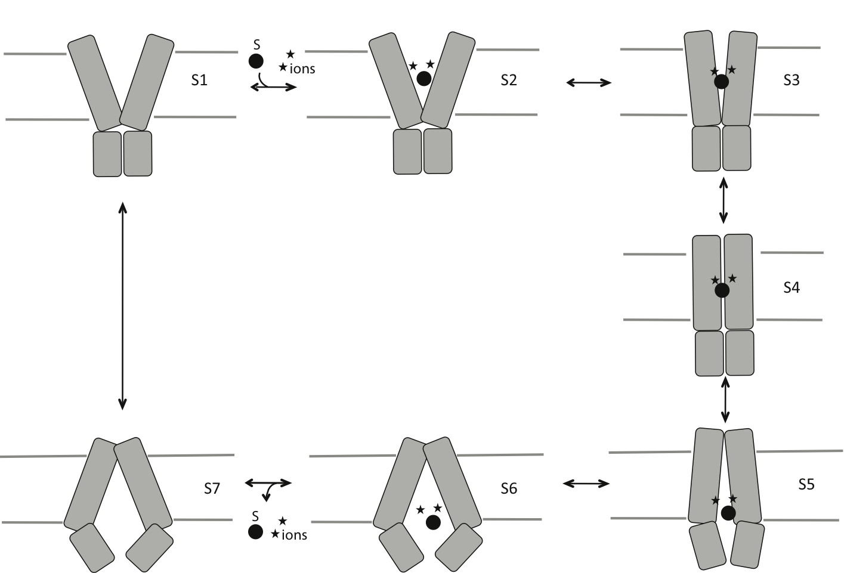

Figure 2
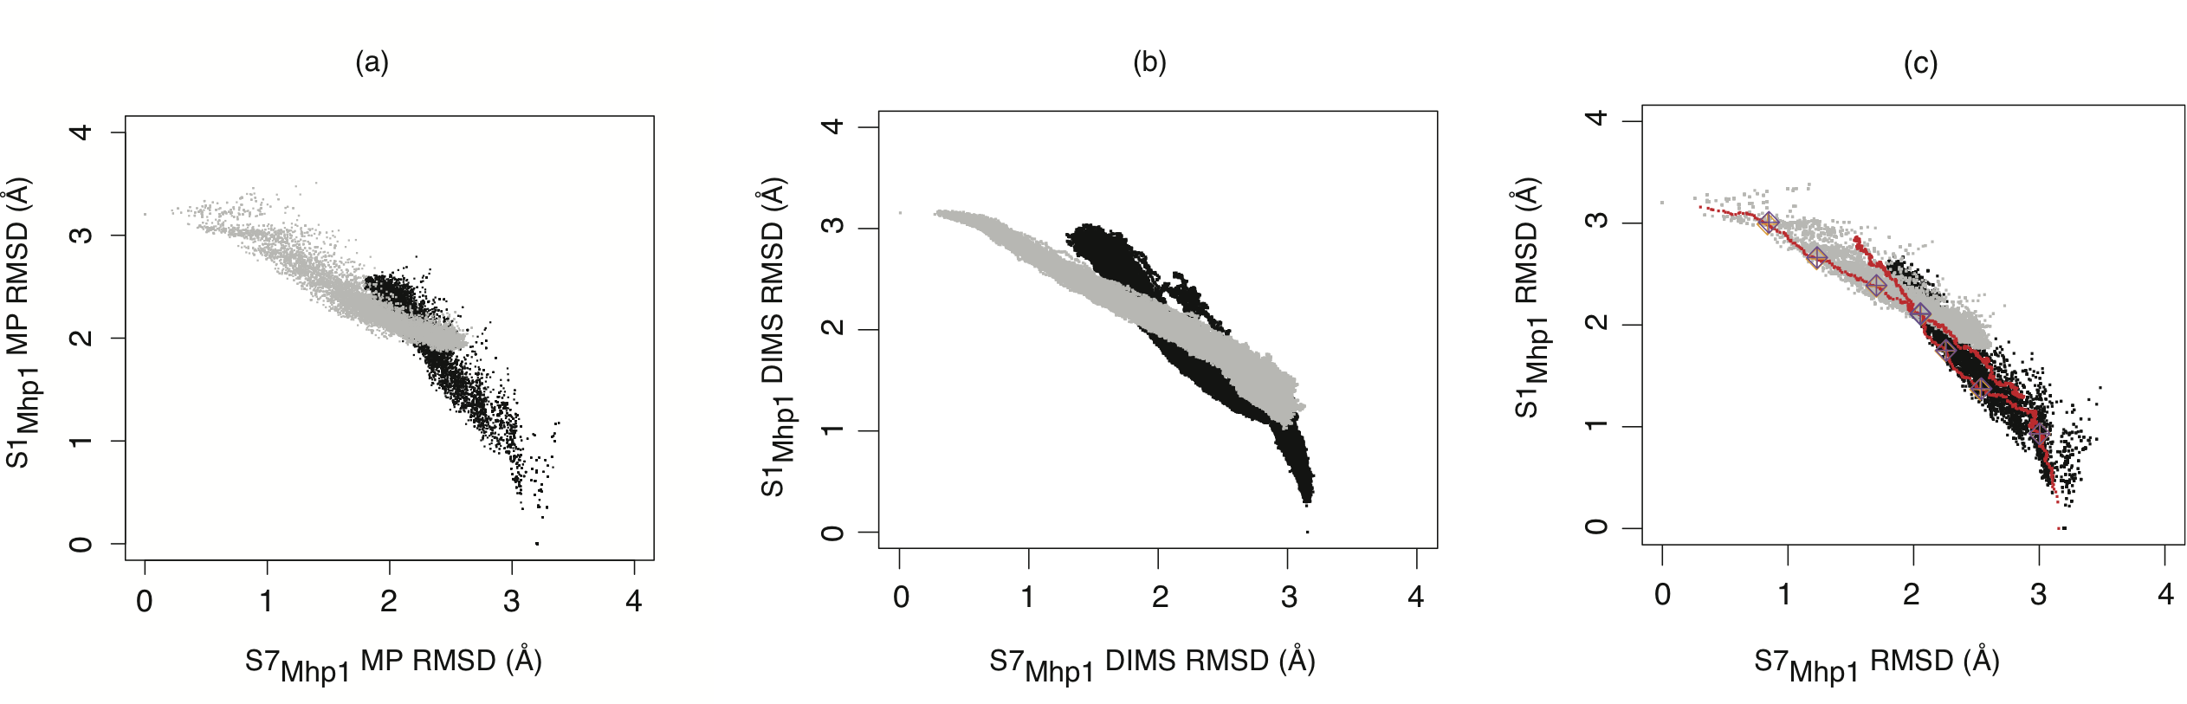
Figure 3

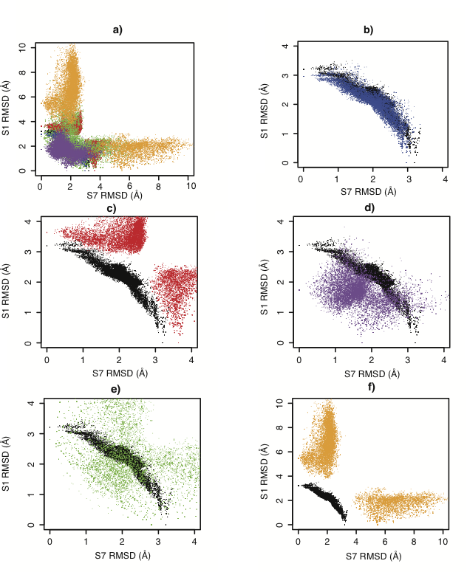

Figure 4

A.
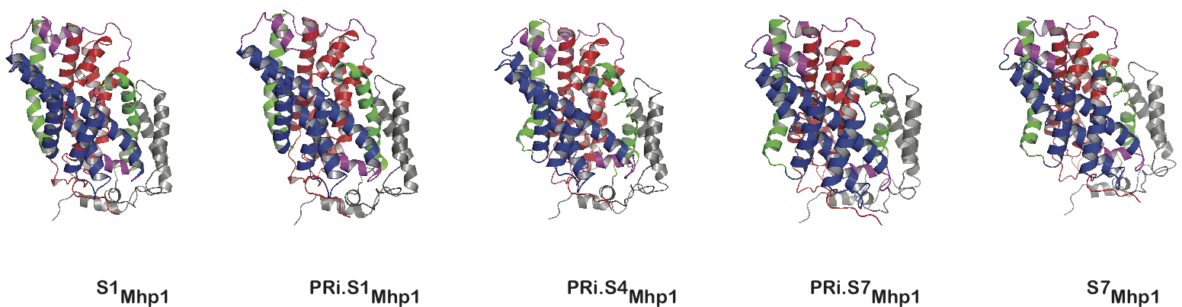

B.
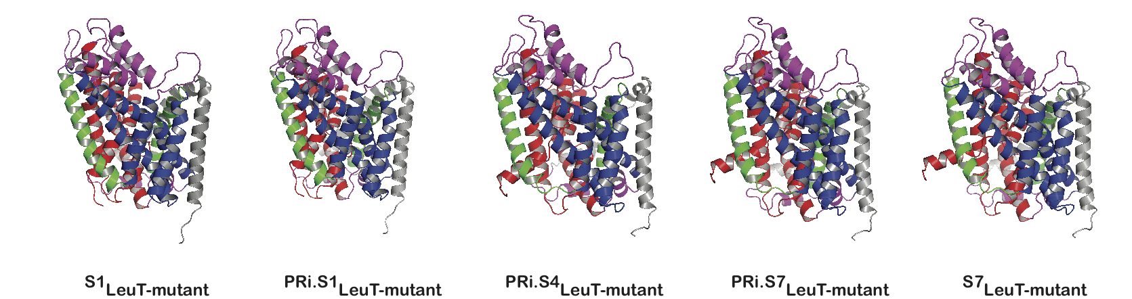

Figure 5
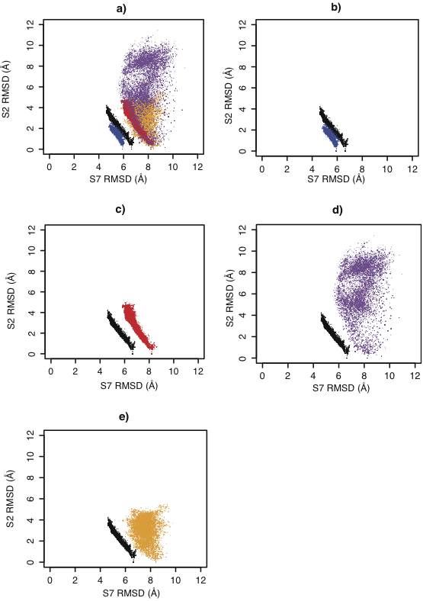
Figure 6

